# SLM Create the Monthly KPI Status Report Procedure

Service Level Management

**Purpose**

This procedure explains how to create and publish the Monthly KPI Status Report.

**Related Policy**

* [IT Service Management Policy](https://sharepoint.jackson.com/sites/integrity/_layouts/15/WopiFrame.aspx?sourcedoc=%7be34fe42a-654a-469a-9d38-6612f00486dc%7d&action=view)

**Audience**

The following groups are responsible for adhering to this document:

* Service Level Management

**Procedure**

|  |  |
| --- | --- |
| Step | Action |
| 1 | US Capacity Planning will send an email with a link to the *KPI Summary For Jackson* Power Point document.    Click on the link.  The information in this document will be used to create the Monthly KPI Status Report*.* |
| 2 | Open up the previous month’s *KPI Status Report.* located at:  S:\Service Delivery\Monthly Status Report\YYYY  This is the document that needs to be updated with information from the *KPI Summary for Jackson* document. |
| 3 | Edit the following information on the first page.   * Submitted by: Type in your name * Date: Type in the date that the report is being prepared.   **Note:** The Monthly KPI Status Reportmust be published by COB on the fifth business day of the current month.   * Skip the second page. This will be covered in Step 8. |
| 4 | The third and fourth pages are for the Tier 1 applications.   1. Insert a new slide into the *KPI Status Report*.  * Click “Insert” at the top of the screen * Click the “New Slide” icon. * Select the “Blank” option      1. Copy the second slide (Tier 1 applications) from the *KPI Summary Report* for Jackson and paste it (using the second paste option “Paste Keeping Source Format”) into the blank slide of the *KPI Status Report.*   **Note:** This is done to avoid confusion between the two reports.     1. Look at Tier 1 (Page 3) of the *KPI Status Report* and take note of what the last application on that page is. 2. On the Tier 1 page (Page 3) of the *KPI Status Report,* right click anywhere in the table. 3. Select the “Delete Table” option. This will remove last month’s content from the page.      1. In the new slide that features the Tier 1 information you have pasted in, highlight and copy from the Application / Date bar down to the application noted in step b) above. 2. Right click and select the second paste option “Paste Keeping Source Format”.   **Note:** If you do not selet this option, the colors will not change based on the  data in the cells.   1. Click on the box you just pasted in and then click the “Arrange” icon at the top of the screen.  * Select “Align” * Select “Align / Center”        1. On the second Tier 1 page (Page 4) of the *KPI Status Report*, right click on anywhere in the table. 2. Select the “Delete Table” option. This will remove last month’s content from the page. 3. Return to the new slide that was created. Highlight and cut the remaining Tier 1 applications information. Include the Application / Date bar row. 4. Right click and select the second paste option “Paste Keeping Source Format”.   **Note:** If you do not selet this option, the colors will not change based on the  data in the cells.   1. Click on the box you just pasted in and then click the “Arrange” icon at the top of the screen.  * Select “Align” * Select “Align / Center”  1. Delete the new slide that was created. It is no longer needed 2. Verify the percentages in the previous month’s column against the Monthly SLA report. Sometimes the numbers on the KPI report will need to be rounded up or down. 3. Print off the *KPI Status Report* that was created in the previous month. 4. Ensure that the percentages for all of the previous 12 months match what is on the current report that is being created. In the event that any numbers were rounded up, the percentages could have changed, causing the cells to go red and reporting an incorrect SLA. If this is the case, update the cell to match what it was the previous month. 5. If any new applications have been added to the KPI report, data will not appear in all of the cells on the report. These blank cells should be colored gray. |
| 5 | The fifth page of the *KPI Status Report* is for Tier 2 applications..   1. On Page 5 featuring the Tier 2 information of the *KPI Status Report*, right click on anywhere in the table. 2. On the Tier 2 page (Page 5) of the *KPI Status Report*, right click on anywhere in the table. 3. Select the “Delete Table” option. This will remove last month’s content from the page. 4. In the *KPI Summary Report.* Highlight and copy the information in Slide 3 (Tier 2 applications) including the Application / date bar. 5. Right click and select the second paste option “Paste Keeping Source Format”.   **Note:** If you do not selet this option, the colors will not change based on the  data in the cells.   1. Click on the box you just pasted in and then click the “Arrange” icon at the top of the screen. 2. Select “Align” 3. Select “Align / Center” 4. Verify the percentages in the previous month’s column against the Monthly SLA report. Sometimes the numbers on the KPI report will need to be rounded up or down. 5. Print off the *KPI Status Report* that was created in the previous month. 6. Ensure that the percentages for all of the previous 12 months match what is on the current report that is being created. In the event that any numbers were rounded up, the percentages could have changed, causing the cells to go red and reporting an incorrect SLA. If this is the case, update the cell to match what it was the previous month. 7. If any new applications have been added to the KPI report, data will not appear in all of the cells on the report. These blank cells should be colored gray. |
| 6 | The sixth page of the *KPI Status Report* is for Infrastructure and Report & File Deliveries.   1. On Page 6 of the *KPI Status Report*, right click anywhere in the table under the Infrastructure title bar. 2. Select the “Delete Table” option. This will remove last month’s content from the page. 3. In the *KPI Summary Report.* Highlight and copy the information in Slide 4 – Infrastructure, including the Application / date bar. 4. Right click and select the second paste option “Paste Keeping Source Format”.   **Note:** If you do not selet this option, the colors will not change based on the  data in the cells.   1. Click on the box you just pasted in and then click the “Arrange” icon at the top of the screen. 2. Select “Align” 3. Select “Align / Center” 4. On Page 6 of the *KPI Status Report*, right click anywhere in the table under the Report & File Deliveries section. 5. Select the “Delete Table” option. This will remove last month’s content from the page. 6. Return to the *KPI Summary Report.* Highlight and copy the information in Slide 5 – Report & File Deliveries, including the Application / date bar. 7. Right click and select the second paste option “Paste Keeping Source Format”.   **Note:** If you do not selet this option, the colors will not change based on the  data in the cells.   1. Click on the box you just pasted in and then click the “Arrange” icon at the top of the screen. 2. Select “Align” 3. Select “Align / Center” 4. Verify the percentages in the previous month’s column against the Monthly SLA report. Sometimes the numbers on the KPI report will need to be rounded up or down. 5. Print off the *KPI Status Report* that was created in the previous month. 6. Ensure that the percentages for all of the previous 12 months match what is on the current report that is being created. In the event that any numbers were rounded up, the percentages could have changed, causing the cells to go red and reporting an incorrect SLA. If this is the case, update the cell to match what it was the previous month. 7. If any new applications have been added to the KPI report, data will not appear in all of the cells on the report. These blank cells should be colored gray. |
| 7 | The seventh page of the *KPI Status Report* is for OLA Breached Tickets.   1. Print off the Summary page of the *Monthly OLA Breached Report* for the previous month at:   O:\Service Delivery\Service Level Management\Reporting\Monthly OLA Breached Report  **Note:** The monthly report is posted on Sharepoint in this location:  Report Storage > Monthly Reporting > SLM > Monthly Production OLA Breached Report > YYYY   1. Using the corresponding data from the Monthly OLA Breached Report, manually fill in the data for the previous month.      1. Add the number that has been added in each row to the YTD column to produce a new YTD total 2. Calculate the percentage for the “% Breached Tickets” row for the previous month by using the following formula:   **Total Breached Tickets / Total Incident Tickets PGDS Total X 100%**     1. Calculate the percentage for the “% Breached tickets” row for the YTD column by using the following formula:   **Total Breached Tickets / Total Incident Tickets PGDS Total X 100%** |
| 8 | Update the second page with SLA and OLA summary information.   1. If any of the SLAs are in red for the month, add the details of the Missed SLA from the Monthly SLA Report to the second page. This should include:  * The Service Target / Metrics information * Any days in which the SLA was missed during the previous month, complete with comments.   ***Example:***   * Service Level Agreement KPI   + **Commissions Checks Fin.** *Target: 98.00% Mon-Fri 11:00*     - 04-04-2017, Tue 0.00% INC1220979 Month / Quarter End processing.  1. If no SLAs were breached, add the following comment to the “Service Level Agreement KPI” section:   *No KPI SLAs were breached.*   1. Add a comment regarding the Breached OLAs, using the information from Page 7 of the KPI report.   ***Example:***   * Operational Level Agreement KPI   + - OLA Breached Incidents 7.63% - There was a total of 8,765 JTS tickets with service target OLAs and 669 of those were breached.  1. Add any pertinent comments in regards to SLAs / OLAs.   ***Example:***   * Additional Information   + - Finalizing SLA Contract for Jackson Operations – adding eFeeds and updating stale content. |

**Appendix A – First Page Example**

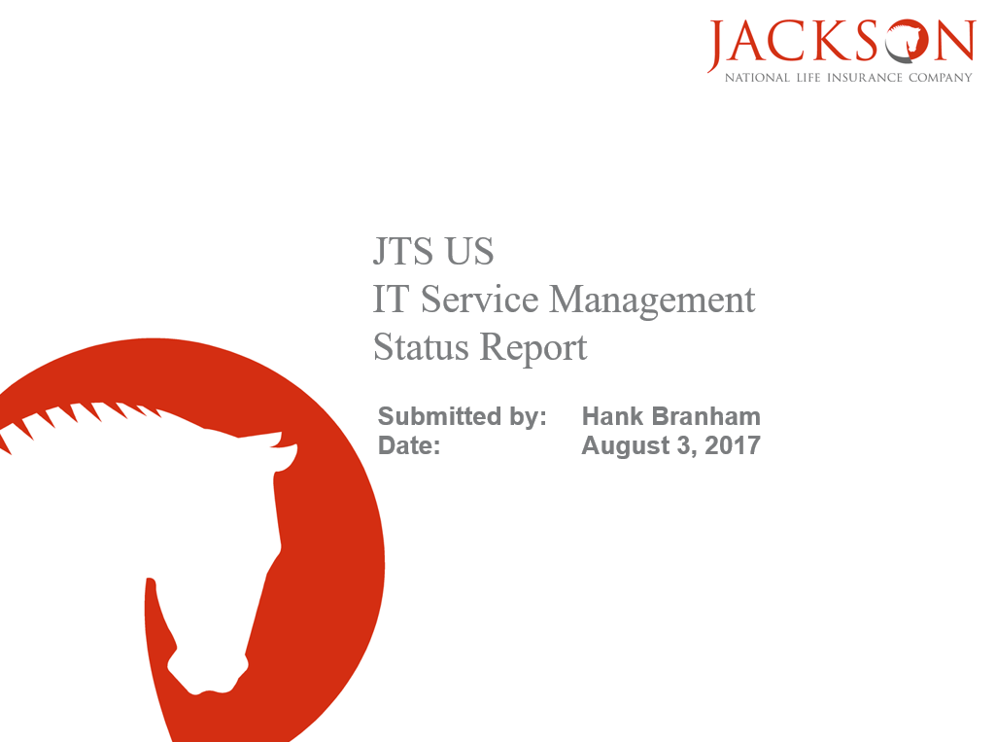

**Appendix B – Second Page Example**

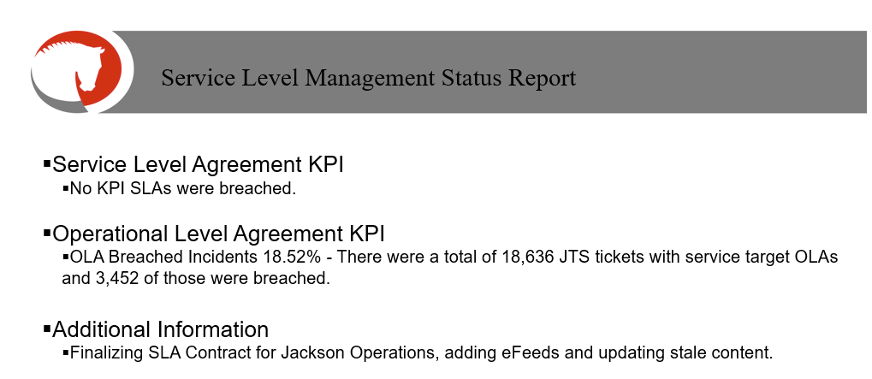

**Appendix C – Third & Fourth Page (Tier 1) Examples**

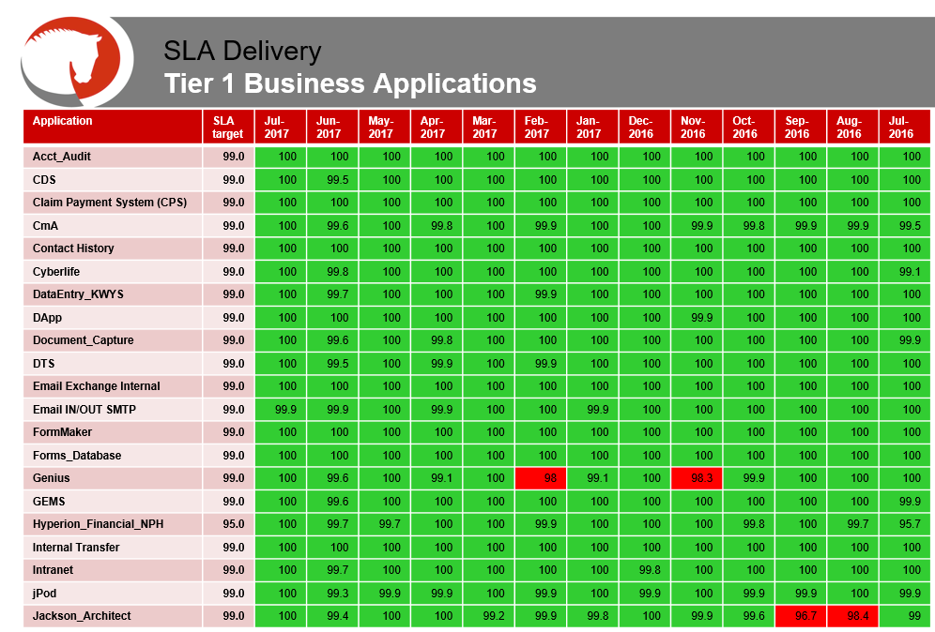

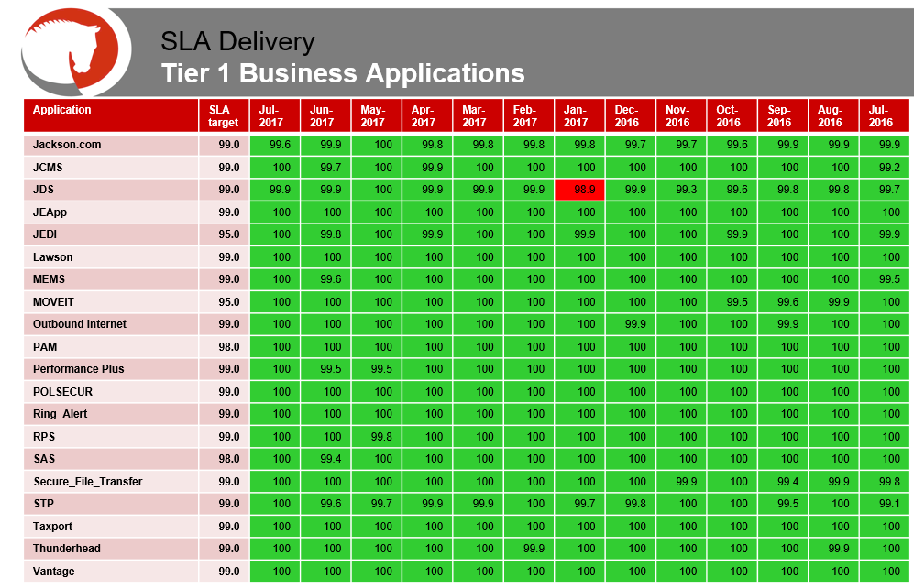

**Appendix D – Fifth Page (Tier 2) Example**

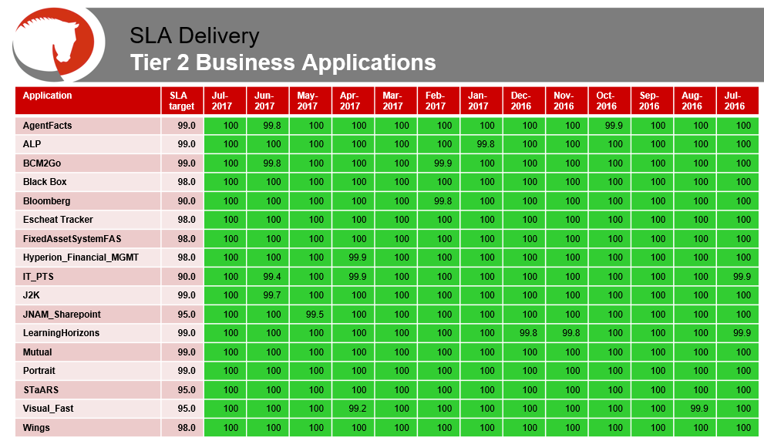

**Appendix E – Sixth Page (Infrastructure / Report & Deliveries) Example**

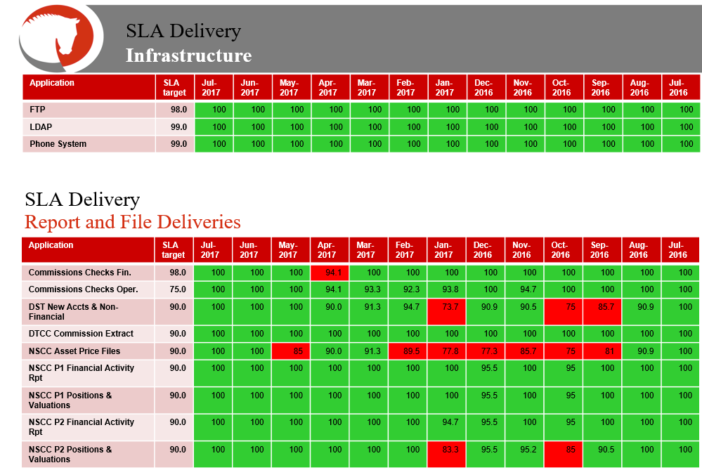

**Appendix F – Seventh Page (Breached Tickets)**

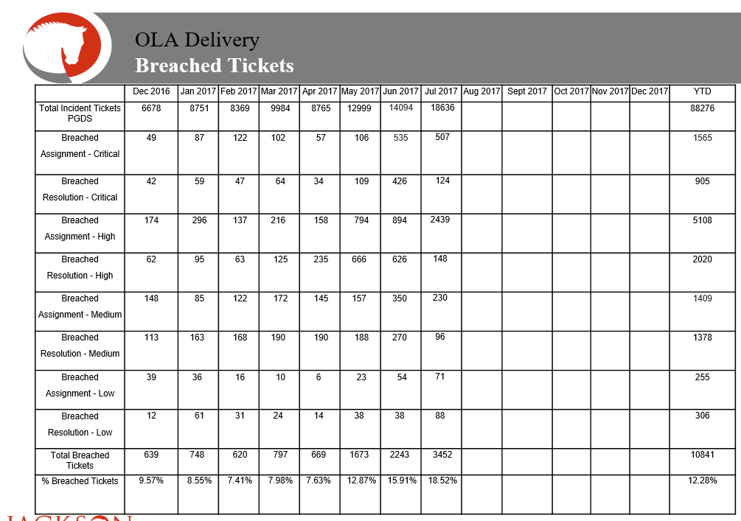

**Modification**

The following associates can make modifications to this document:

* Manager, Service Level Management
* Director, IT Service Management
* Vice President, Service Delivery
* Chief Technology Officer, PGDS

|  |  |
| --- | --- |
| Service Level Management Process | |
| Responsible Party: Anna Carter, Manager, Service Level Management Approving Authority: Abdul Golden, Director, IT Service Management | Date Created: 08/08/2017 Last Modified:  Last Reviewed: |